From the Communications Director, Maja Kowalski.

Hi All,
Our dynamo communication team is working hard to bring you 3 major improvements to the way we interact with you, our members. We will be revealing these great initiatives one by one in each of the newsletters, and here is the first one.
Single-Sign-On for PMI.org and PMISydney.org websites! Starts May 1, 2013.
I believe this is something that most (if not ALL) of you have been waiting for: having your PMI Global www.pmi.org and the PMI Sydney Chapter www.pmisydney.org website log ons synchronized so you only need to remember one set of credentials. Here is the good news – It’s coming! As of May 1, we will have the single-sign-on functionality enabled for PMI Sydney website, which will mean:
- Your log in details for PMI Sydney website www.pmisydney.org will change to match your current log on credentials for PMI Global www.pmi.org

- If you are currently logged onto the PMI Sydney website (and have the ‘Remember me” box ticked) you will be logged out when we switch over to the single-sign-on and you will need to log back in with your PMI Global username and password.

- All username and password resets and retrievals will be managed via myPMI section on the PMI.org website. Once you’ve reset your password there, your PMI Sydney website password will also be automatically updated to match your new PMI.org password
The single-sign-on means less work for you and a more efficient way to manage your PMI Global and PMI Sydney web accounts. If you have any questions about the single-sign-on feature, please do not hesitate to contact me.
Welcome to Kally Tzuhui Wu and Tony Azrak!
It’s with great pleasure that I introduce two new members to the PMI Sydney Chapter Communications Team: Kally Tzuhui Wu and Tony Azrak. Kally and Tony are working on introducing the latest technology solutions, yes gadgets!, to the PMI Sydney Chapter so we can help our members stay connected and involved in chapter activities easier, faster and whilst on the go. I will reveal more about this initiative in the next issue of the Critical Path.
In the meantime, please take this opportunity to meet Kally and Tony:
The compassionate Kalley, Tzuhui Wu, who has relocated to Sydney in Aug 2012 and joined the PMI Sydney chapter in Mar 2013. She has 10 years’ experience in finance including 5 years in equity investment in London and more than 5 years in Taiwanese banking. She loves to get involved in local community activities which create value.

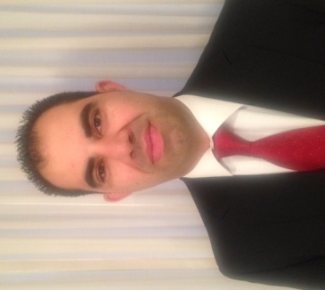
The Tremendous Tony Azrak. Tony recently joined Sydney Chapter, with over 6 years managing IT software projects. He is PMP certified and currently working towards obtaining a Master of Project Management. Tony is currently working on a number of IT/Infrastructure and eLearning projects, and is committed to current market best practices, continuous business improvement and assisting the community. He enjoys in his spare time live music, film and playing tennis.
Enjoy the sunny autumn days!

All the best
Maja

PS: Have you registered for the PMIAUS13 Conference? There is still time to do that, don’t delay Register Now! Go to: http://www.pmi.org.au/register-here/ This is a not-to-be-missed event of all times (yes, the inaugural PMI Australia Conference happens only once!!!)

